CENTRAL VIGILANCE COMMISSION (CVC), NEW DELHI
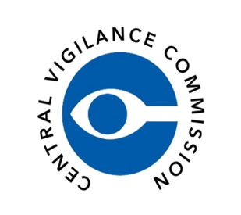
ALL INDIA COUNCIL FOR TECHNICAL EDUCATION
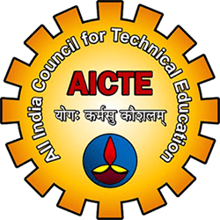

KALINGA UNIVERSITY, RAIPUR (C.G.), NEW DELHI
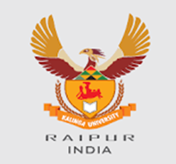
FACULTY OF TECHNOLOGY
Theme: “सतर्कता: हमारी साझा जिम्मेदारी”
“Vigilance: Our Shared Responsibility – Education for Integrity and Transparency”

DAY 5 – Remembering Patel: Integrity in Leadership & Valedictory Ceremony
Date: 31 October 2025 | Time: 11:00 AM – 2:00 PM
Venue: WBFF 02 (Hybrid Mode)
Organized by: Faculty of Technology & Faculty of Education, Kalinga University, Raipur (C.G.)
In Collaboration With: Shaheed Veer Narayan Singh Shodhpeeth, Kalinga University, Chhattisgarh
Under the Guidance of: All India Council for Technical Education (AICTE) and Central Vigilance Commission (CVC India)
The Faculty of Technology and Faculty of Education jointly concluded Vigilance Awareness Week 2025 with two major events on 31st October — a special lecture in the morning and a valedictory ceremony in the afternoon.
The morning session, ‘Remembering Patel – Integrity in Leadership,’ honored the birth anniversary of Sardar Vallabhbhai Patel. Prof. Dr. Ajay Kumar Shukla, HOD, Hindi, Faculty of Arts & Humanities, delivered an inspiring lecture on Patel’s ideals of unity, ethical governance, and public integrity.
The afternoon session, ‘Celebrating Integrity – Valedictory & Prize Distribution,’ summarized all week-long activities including the Integrity Pledge, Essay Writing, Debate, and Poster Exhibition. Prof. Dr. Shraddha Verma, Dean, Faculty of Education, and Prof. Dr. V.C. Jha, Dean (In-Charge), Faculty of Technology, appreciated participants and faculty for their dedication to ethical awareness.
Awards were presented to Sneha (Essay Winner) and Sheetal’s Team (Debate Winners). The ceremony concluded with the reaffirmation of the National Integrity Pledge, celebrating the success of Vigilance Awareness Week 2025 at Kalinga University.

Official Links:
Central Vigilance Commission (CVC): https://www.cvc.gov.in
All India Council for Technical Education (AICTE): https://www.aicte.gov.in
Kalinga University: https://www.kalingauniversity.ac.in
#VigilanceAwarenessWeek2025 #IntegrityFirst #CVCIndia #AICTE #KalingaUniversity #EthicsInEducation #TransparencyMatters #SatarkBharat #OurSharedResponsibility #SardarPatelJayanti #IntegrityInLeadership
